**Underwood Community**

**Council Connections**

**Newsletter 06/2019**

**Next Council Meeting Wednesday June 19, 2019 at 6:00 at the Park Center**

We plan to have regular UCC meetings on the third Wednesday of each month except for September, when we sponsor the community picnic, and skip the months of December and January.

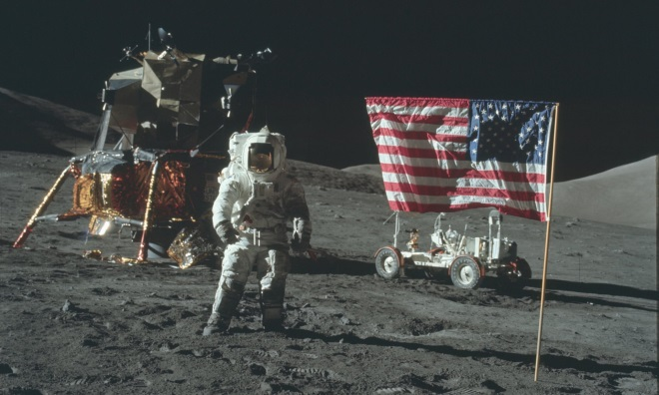

**Astronomy Presentation**

**June 19 at 6:00**

Les Hastings is a Solar System NASA Ambassador who lives in the Gorge and writes an astronomy column for the Skamania County Pioneer. He will talk about the 50th year celebration on July 20, 2019 of the NASA landing on the moon and also show photos of what can be seen this time of year in our local Gorge sky.

A short UCC business meeting will follow the presentation.

Website: **Underwood community.org**

Facebook: **Underwood Washington Community Council**

**Red Cross Blood Drive**

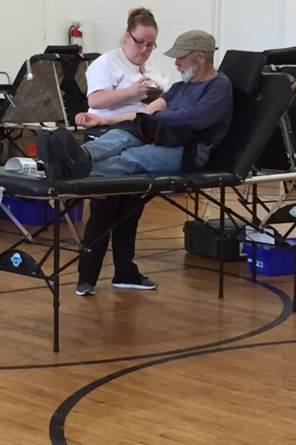

Many brave souls recently donated blood on Friday June 7. Pictured above is Keith Fredrickson, UCC former President. Many thanks to UCC treasurer Lisa Brown for arranging the blood drive in the Underwood Park Center.

**UCC officers:** Cam Thomas, Pres.; Darla Johnston, Vice Pres.; Kathy LaMotte, Secretary; Lisa Brown, Treas.; Mary Kapp, Communications Manager; Keith Fredrickson, former Pres.

**Volunteer Hours for May 2019**

The grand total reported for UCC, UPRD and community members was 109 (plus) hours. At $15/hr. that is worth $1,735 donated for the month. Thanks to all who volunteered to put flags on the military graves and clean head stones for Memorial Day week end. 16 hours were spent doing that. In addition, UCC members volunteered 28 hours and the Park Commissioners volunteered 109 hours.